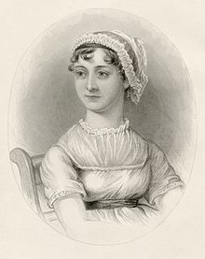
“How pleasant it is to spend an evening in this way! I declare after all there is no enjoyment like reading! How much sooner one tires of anything than of a book!” --Pride and Prejudice

Miss Jane Austen’s Book Club

Let us gather to read what Jane Austen read, and books about her and her era, as well as her own immortal works. We will see what influenced her intellectual and aesthetic choices, and then appreciate the visions that sprung from her own imagination.
Sept. 10, 2013 at 7:00 pm
Selections from the Penguin Book of Romantic Poetry
See BooksInc. Website for specific selections or request them at jolivzqz@yahoo.com
at
Books Inc. in the Marina
2251 Chestnut Street, San Francisco, CA 94123

Future selections:
Nov. 12 – Jane Austen’s “Sense and Sensibility”
Jan. 14, 2014 – Fanny Burney’s “Evelina”
March 11 – Jane Austen’s “Pride and Prejudice”

Books Inc. – Marina will have copies of these selections available for purchase (when possible) and book club attendees get a 15% discount if they mention the book club. Please call 415-931-3633 to confirm availability.

To acquire more information, please email jolivzqz@yahoo.com

Transportation: Meter Garage on Pierce between Lombard and Chestnut; paid garage on Lombard between Fillmore and Webster (entrance on alley behind); Chestnut Street served by 30 Stockton Muni line,
and one block from Lombard Street lines 28 19th Ave. and 43 Masonic.

